**Assignment 2**

**MIS701 – Business Requirement Analysis**

**Submitted by: Group 2**

|  |  |
| --- | --- |
| **Student Names** | **Student ID** |
| **Gulbaz Khan** | **219296087** |
| **Surabhi Santra** | **218729092** |
| **Hrishikesh Joshi** | **219588468** |
| **Jay Khetwal** | **218644887** |

**A2 P1: Requirement Analysis**

***Figure 1: House of Quality (Sourcing software: Edraw max)***

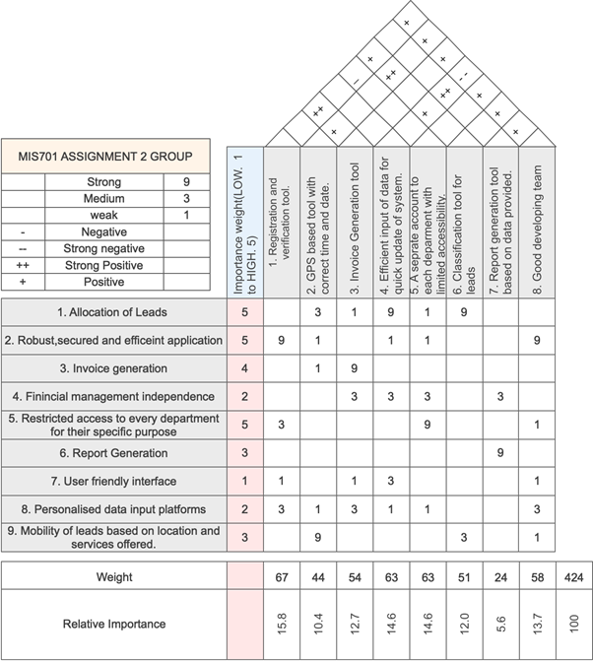

# **Analysis of business needs stakeholder requirements and their importance**

After elicitation of needs of all the stakeholders, the classification of business requirements is done in house of quality. These needs reflect the most important business requirements which are currently needed to business to perform better by taking in account the needs of every stakeholder analysed before.

The most importance is rated as 5 and the least important needs are given a rating of 1. The allocation of leads is rated 5 because it is the main part of expanding the cuida care business and to make sure the franchisees can start working as the leads to convert them into clients as soon as possible. The robust, secured and efficient application is rated 5 as it is the backbone of any business. Any fault is this can affect the reputation of cuida care which has been built by years of successful business. It was also a demand of most of the stakeholders to develop such an application which can cater their all needs. Also, Restricted access is given a rating of 5, because it serves many purposes of each department separately such as marketing managers, training department, account’s department and as well as the franchisees.

After incorporating the needs of the business and as well as the preferences of stakeholders, rest of the business requirements are given the rating according to importance of everyone. The user-friendly application is given the least importance as the training within the app the can provided to train to staff to successfully use the application according to their needs.

# **Analysis, Recommendation and Justification of Solution Requirements of relationship matrix and correlation matrix.**

The incorporation of functional and non-functional solution requirements has been given in the house of quality to cater the needs of business requirements and successful implementation the application. Eight solution requirements are used into the house of quality which are most important to satisfy the business requirements. Registration and verification have a strong relation with the robust, secured and efficient system that is why it’s given a number 9. In this format, 9 states a strong relationship, 3 states a medium and 1 state a weak relationship. Based on this format, the relationship matrix is made. The boxes which are empty are the one which do not have any relationship with the specific business need. One solution can cater many business needs or should have a relationship with at least one of the business needs. The table below states the relationship between the solution requirements and the business requirements.

***Table 1: Relationship Matrix***

|  |  |  |  |
| --- | --- | --- | --- |
| Solution Requirements | Business requirements | Relative importance | Impact |
| 1. Registration and verification tool | 2,5,7,8 | 15.8 | High |
| 2. GPS based tool with correct time and date. | 1,2,3,8,9 | 10.4 | Medium |
| 3. Invoice Generation tool | 1,3,4,7,8 | 12.7 | Medium |
| 4. Efficient input of data for quick update of system. | 1,2,4,7,8 | 14.6 | High |
| 5. A separate account to each department with limited accessibility. | 1,2,4,5,8 | 14.6 | High |
| 6. Classification tool for leads | 1,9 | 12.0 | Medium |
| 7. Report generation tool based on data provided. | 4,6 | 5.6 | Low |
| 8. Good developing team | 2,5,7,8,9 | 13.7 | High |

This table above shows which solution requirement has a relationship with a specific business requirement. The relationship matrix in the house of quality (Figure 1) shows the exact strength of relationship with each other.

After analysis of the relationship matrix, it can be seen from the data that the most important in the weights analysed is the registration and the verification tool. This solution is the basic and number one step while making any application. It caters the most important requirements of business. Second priority is given to a non-functional and a functional tool because both impact the business needs at the same weight. A separate accessibility account is allowing the application to give access and different functions to the main stakeholders which will be playing part in operating the business such as the managers and the franchises. Also, the time-to-time input of data is important to run the business smoothly. Thirdly, Good developers are required to execute these all solutions which we suggested. Though it is a non-functional requirement but still it plays an important part in the reputation and quality of the application. After this, the classification of leads and invoice generation have almost the same weights, as many important stakeholders has the business requirements which can only be fulfilled by these solutions. Lastly, the report generation tool has the lowest weight and impact on the application as it only satisfies the needs of one stakeholder which is marketing manager who wants to see the reports.

***Table 2: Summary of the correlation matrix***

|  |  |  |
| --- | --- | --- |
| Correlation | Solution requirements | Justification |
| Strong positive (++) | 1&3.  2&6.  4&7. | These have a strong correlation as the impact of one is favouring the other solution requirement. |
| Positive (+) | 8 has a positive with all except with 4. | A good developing team is the backbone of the software development and implementation, so they have positive relation with all the functional requirements. |
| Strong Negative (- -) | 8 & 4. | They both are non-functional solution requirements so if we focus on one we may not be able to allocate more people towards the other requirement. |
| Negative (-) | None. | All the solution requirements are in-line with the business requirements. Each solution requirement solves one or more of the business requirements. So, we don’t have any negative correlation. They are not dependant on each other so can be carried out separately without effecting the other negatively. |

At the end of this part, based on the analysis of house of quality, we recommend to:

1. Not to ignore any of the solution requirement as each one has some importance. If any of that is ignored it may affect the stakeholders.
2. Try to merge the business requirements to successfully implement the application in a comprehensive manner.
3. Analyse the risks of not giving importance according to the weights of house of quality.
4. Go forward with the plan of implementing the application and its basic tools as we suggested in the house of quality.

# **Elicit Requirement and user needs**

**Business Requirements:**

1. The app should be able to enable the new franchisees to undertake their activities.
2. Enable the management team of Cuida care to monitor franchisees activities such as business activities.
3. The app should be able to calculate of royalty through income and expense.
4. Generate reports for marketing purposes.

**Stakeholder requirements:**

1. The new franchisees can see the leads assigned to them through call centre.
2. Security of the system
3. Management of personal information by the franchisees. (Profile, experience and contacts)
4. Franchisees should be able to see the allocated leads.
5. Franchisees should be able contact and convert leads into clients.
6. This app should be able to update leads status into client status.
7. Service created should be updated with data and time before the services are done.
8. Efficient invoice generation for the customers even before the services are done.
9. Franchisees can manage their banking, profit and loss and accounting needs within the app.
10. Call centre administrators can cancel the leads or clients.
11. Call centre administrators can reassign the clients to any franchisee.
12. Franchisee should be able to update their preferred location and availability to provide registered services.
13. The services registered by the franchisees should be updated and restrictions on getting clients which the franchisees do not offer.
14. Marketing managers should be able to view the sales performance.
15. Training department can update and upload training manuals to help franchisees with their queries.
16. Account’s managers can generate invoice for franchisees with breakdown of the charges occurred.

**Solution Requirements**

**Functional:**

1. Registration of an account on the app.
2. The app should have a verification process tool.
3. A personal profile management tool for every registration.
4. Status upgrade and management tool with date and time.
5. Invoice creation tool should be present in the application when the leads are successfully booked a service.
6. Integration of account management system.
7. More authority to call centre administrators to manage and transfer the clients.
8. GPS based location services for the franchisee for location preference.
9. Application should be able to ask the preferences of the franchisees for their registered services.
10. Registered services and client classification according to the franchisee’s services.
11. Automatic report generation tool with limited access to the marketing managers.
12. Training manual tool for training department.
13. Invoice generation tool for account’s managers.

**Non-Functional:**

1. Quick input of information in the app.
2. Details of services to be collected from each franchisee.
3. Call centre staff training for proper use of assigning the leads.
4. Details of the financial data from the franchises to input in the app.
5. Training to use the application within the app.
6. Good developing team

**Transition requirements:**

1. Call centre staff training for proper use of assigning the leads.
2. The business should grow with time.
3. The franchisees should be interested in investing in cuida care.

**A2 P2: Use-Case Diagram:**

**The use-case diagram for the entire CUIdaOnline mobile app system** is shown below.

The Franchise manager must register itself with Cuida Care Call Centre Administrative staff including the information about the preferred territories and the availability to work.

The verification process is completed by the Administrator of the External verification agency and Franchisee information is verified; the Franchisee can then access to the lead generated by the system.

The Call enter administrative sends the leads to the operation manager, to check the qualification of the franchise and allot leads accordingly.

Franchisee needs to contact the client and leads are then converted into clients and the status is updated to the Cell centre administrative.

Once the client confirms for the service, an invoice is generated for the clients to make the payment, the franchisee should be able to create invoices even when the service is not completed.

Monthly invoice is generated to Accounting manager of the Franchisee to make the payment for the Base Monthly Franchise Fee.

There are four payment methods including payment by cash, electronic payment, Voucher and card.

Once the payments are made, information is updated in the system.

Once the invoice is generated, the service provision information should be updated in the system with the client details, service date and time.

The Call centre administrative can cancel or transfer leads assigned to particular franchisee, it is assumed that this can be done so that no franchise gets overbooked and affect the quality of the services provided to the clients.

Report generation is done by the Marketing Manager who monitors the revenue and sales performance.

It is assumed that Sales Manager collects and analyses the sales leads and the strategy to meet the demand and supply.

The Training Manager updates all the Training Manuals, according to the requirement.

**Advantages of a Use-Case Diagram:**

Use case helps to capture the functional requirements of a system.

It is traceable.

It can serve as the basis for the estimating, scheduling, and validating effort.

It can evolve at every iteration by a method of capturing requirements, to development of guidelines to programmers, to a test case and finally into user documentation.

Use cases have proved to be easily understandable by business users, and so have proven an excellent bridge between software developers and end users.

***Figure 2: Use-case diagram for CUIdaOnline mobile app:***

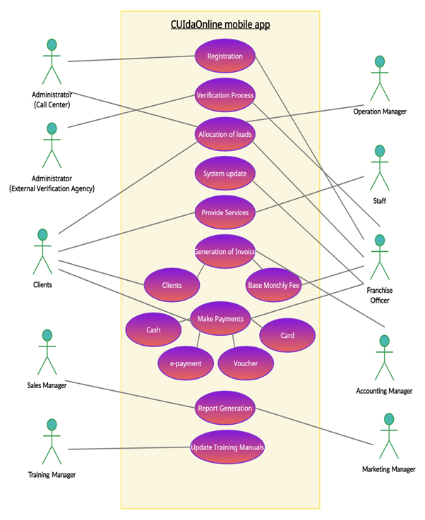

**A2 P3: Sequence Diagram:**

**The sequence diagram of the use case selected is Lead Generation and Allocation System.**

It shows interactions between that arranged objects in time sequence. The diagram illustrates the sequence of messages between the objects. The importance of the sequence diagram is that it is a step that connects the use-case and the domain class diagram design. It is important to visualize the events that occur in a complex system.

The following events occurs in the process of Lead generation and allocation system:

**Event 1:** It is assumed that the clients register their contact details with the Call centre administrative.

**Event 2:** Lead is generated by the Generation of Leads System.

**Event 3:** The call centre administrator sends these leads to the operation manager to check if the franchisee is qualified enough to provide specific services.

**Event 4:** The operation manager then rejects or allocate leads to the franchisee officer.

**Event 5:** Once the leads are accepted by the franchisee, they contact the client and convert the lead into a client.

**Event 6:** The information of the status and the service provision date and time is updated in the Generation of leads system.

**Event 7:** The Administrator of call centre can reject, or transfer leads assigned to franchisee, it is assumed that the franchisee outrun their capacity and forget to update their availability.

Therefore, once the process of lead generation and allocation is completed, the Franchisee can then move forward with providing services.

**Assumptions:**

Converting the lead into a client is the most important task for the franchisee officer.

To keep it simple, all clients should be assigned by the operations manager to the nearest franchise available according to the geographic segmentation.

Also, all customers should be given the priority to select the nearest franchise services they would want to opt for.

High end clients should be assigned to a well-maintained professional franchise to offer best services to such clients to keep them in the good books for future business relations.

***Figure 3: Sequence Diagram for Lead generation and allocation system***

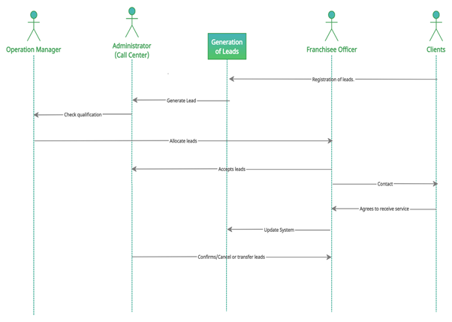

***Figure 4: Domain Class Diagram***

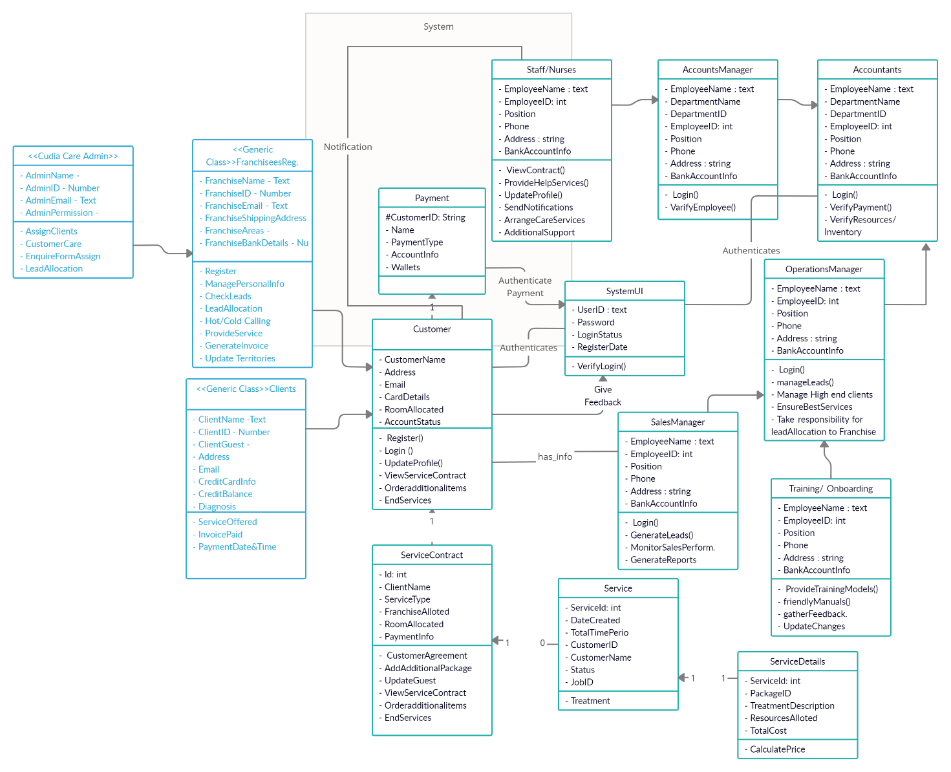

**Domain Class Diagram**

**Analysis and Assumptions:**

In the diagram above, SystemUI is a boundary class that connects various classes in the given portal to carry out all communications between all entities, classes and actors.

Operations Manager (Employee) is the Parent class that involves other child classes such as Account's manager and staff/nurses to allocate leads to different franchisees to be able to convert leads to clients. In the similar way, customer is the parent class between the generic classes, such as franchisees and clients (Group of customers or a party consisting of more than one individual). Therefore, we can assume that all the child classes have similar functionalities of the parent class.

After choosing the service, a service contract can only be created once for the customer. Therefore, an individual customer can only have one service contract at a time. Although, there can be various add-ups in the services provided.

Service here refers to a specific care package that has been selected by the client.

Service details consists of information about client's past treatments/ facilities/ environment received in previous nursing homes or some additional services requested by the client that needs to be highlighted in the current package, since the main reason of moving to a new nursing home is based on the new & advanced services such as digital technologies, catering, transport and shipping services.

One service contract has one service although, sometimes there are more than one service or additional services.

All the employees such as nurses, account managers, sales and operations managers update their Bankdetails into sign up as they all need to be paid.

*(Fakhroutdinov, 2021), (Child Care | Editable UML Class Diagram Template on Creately, 2021), (Yeh-Chun Juan, 2005), (uml diagram for hospital management system | Hospitality management, Engineering programs, Use case, 2021)*

**A2 P4: Business Process Management**

***Figure 5: Business Process Modelling***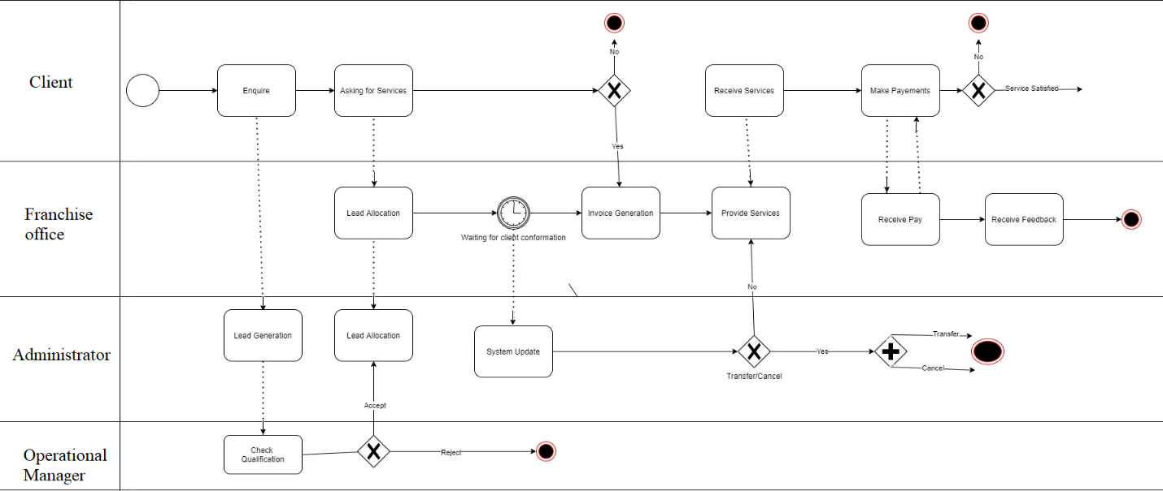

The Figure above illustrates the Business process modeling notation for lead generation process of Cuida Care.

The Diagram shows the flow of business process for the generation of the leads, in other words it can be said that the Business Process management notation is a type of a flow chart.

The Model is divided into three lanes, first one being the client, second one being the franchise office & the third lane is divided into two sub lanes, the Administrator and Operational manager.

The Diagram is divided into 4 lanes, Customer, Franchise, Administrator and Operational Manager. The flow starts from the initialization of process which is when a customer enquiry for the service Then the lead can be generated based on customer’s enquires, The Process then requires the operational manager to check if the customer requests can be satisfied by the franchise or not, if it can be, then the lead is allocated and the invoice is generated and sent to the customer. If the customer needs any additional services, then an updated invoice is sent to the customer, for every change in the service to be done, the system is updated and the process ends if the customer wants to cancel the service or transfer it to another franchise, Once the service has been provided & the payment has been done, it ends the process after taking the customer feedback.

*Figure 5* gives sufficient detail for precise implementation. The BNMP also provide standard language for all stakeholders technical & non-technical, the *Figure 5* can help to bridge the gap between the intention of process and implementation based on sufficient detail & clarity to sequence and business activities.

The Model can be used to improve efficiency and understand the new circumstances that may arise which will give the Cuida care competitive advantage.

Therefore, the above-mentioned figure represents the process lifecycle of the lead generation & allocation for the Cuida care.

**Executive Summary**

Management team, Cuida care

**Overview:**

Cuida care being one of most recognized name in Healthcare & Aged care service industry with skilled & experienced workforce of more than 200 employees, the organization is known to provide efficient healthcare & aged care service. The Company has made its brand name in the industry under the leadership of Emily Thompson and the efficient management team.

As the Cuida care decides to move forward with their new mobile application that makes easier for the franchise to provide services.

**Content:**

The app basically undertakes franchise activities ranging from business activities, franchise activities to calculating royalty of the brand, the training department is working to ensure that franchises are familiar with this latest update, the app also generates marketing reports which can be beneficial for lead generation.

The App is supposed to provide the features like the effective authentication, efficient customer service & call center communication, verification, allocation of leads and updating the databased based on lead allocation, creating & managing invoice and payments and managing the feedback and monitoring the sales performance and generating report.

**The Plan is divided into four sections:**

**The first section** focuses the stakeholder requirement analysis using the house of quality which is a time consuming & complex method, but this method gives a better planning and designing as the voice of customer is effectively taken, this improves customer satisfaction, helps in early determination of requirements, minimizes the initialization costs & improves the quality.

**The second section** focuses on the Use case diagram for the mobile app.

This helps to capture functional requirements of the system; the use cases are traceable and they clearly show the interaction between the system and the actors.

The paths capture the alternative behavior that improves the robustness of system and gives a better understanding, the use case diagram below can work as a bridge between the administrators, developers of the system and the users.

**The third section** focuses on Sequence diagram for lead generation and invoicing to client

and made a domain class diagram, the sequence diagram shows the sequenced process for the generation and allocation of leads, it is very useful for deeper understanding of the system and exposing the opportunities for reusage and simplification and to manage the risks.

The class diagram has divided the system into multiple classes and showing the attribute, operation & relation among them.

**The fourth section** focuses on the Business process model for lead generation which is nothing but a type of flow chart representing the business flow for lead generation. The BNMP shows the business process in such a way that both technical and non-technical stakeholders of the company can understand the process.

This Report is an analysis and understanding of the effectiveness of the application. The focus on understanding the process of lead generation & converting the leads into clients will definitely work in the organization’s benefit.

**References**

Fakhroutdinov, K., 2021. *An example domain model for the Hospital Management System is represented by several UML class diagrams.*. [online] Uml-diagrams.org. Available at: <https://www.uml-diagrams.org/examples/hospital-domain-diagram.html> [Accessed 6 May 2021].

Creately.com. 2021. *Child Care | Editable UML Class Diagram Template on Creately*. [online] Available at: <https://creately.com/diagram/example/i3ndc33f1/Child%20Care> [Accessed 6 May 2021].

Tallyfy. 2021. *Business Process Modeling: Definition, Benefits and Techniques*. [online] Available at: <https://tallyfy.com/business-process-modeling/> [Accessed 7 May 2021].

Citeseerx.ist.psu.edu. 2021. [online] Available at: <https://citeseerx.ist.psu.edu/viewdoc/download?doi=10.1.1.670.213&rep=rep1&type=pdf> [Accessed 6 May 2021].

Pinterest. 2021. *uml diagram for hospital management system | Hospitality management, Engineering programs, Use case*. [online] Available at: <https://in.pinterest.com/pin/553872454150316084/> [Accessed 6 May 2021].